Data Analysis
Task 1
Kiara Angelys Gänger
Western Governor University
D211 | Advanced Data Acquisition

Note: Many steps and instructions are reused from my D210 task

Part 1: Data Dashboards

Copy of Dashboard

Both Datasets
For this task I will be using the same dataset I used in D210. The IBM dataset and the churn dataset. They are both telecommunication companies that collect customer data including Churn status.
- ibm.csv
- churn.csv
- addon.csv

Dashboard Installation
For this task you will complete steps 1 to 4 of the data preparation. Then you will have the option to continue through Steps 5 through 11 to build the dashboard or jump to the upload steps to install the workbook package:
- Connecting to the Server and Database
    - Open the pgAdmin4 application
    - Connect to the PostgreSQL Server
      - Click on Servers on the panel on the left
      - Click on PostgreSQL 13(your server)
      - Database>churn
    - Expand Schemas>Tables
- Preparing the WGU dataset part 1
  - Creating the addon Table
    - Click on Tools on the top menu panel and select Query Tool
    - Copy>Paste the following:
CREATE TABLE addon (
customer_id VARCHAR(20),
InternetService VARCHAR(20),
Phone VARCHAR(3),
Multiple VARCHAR(3),
OnlineSecurity VARCHAR(3),
OnlineBackup VARCHAR(3),
DeviceProtection VARCHAR(3),
TechSupport VARCHAR(3),
StreamingTV VARCHAR(3),
StreamingMovies VARCHAR(3)
);
    - Click the ▶ on the top right
    - On the left in the panel, right click on Tables and select Refresh
  - Loading the data
    - Right click on the newly created table addon and Select Import/Export data
      - Check Import
    - Under File Info
      - Filename find the addon.csv file attached to the submission
    - Format select csv
    - Under Miscellaneous
      - Header Yes
      - Delimiter ,
    - Select Columns on the tab menu
      - Under Columns to Import make sure all columns are filled in 10 total
    - OK >
    - Right click on Tables > Refresh
  - Editing the Customer table
    - Clear the Query Editor
      - Copy>Paste the following:
ALTER TABLE customer
ADD COLUMN source VARCHAR;
UPDATE customer
SET source = 'WGU';
-- Update 'Prefer not to answer' to 'Nonbinary'
UPDATE customer
SET gender = 'Nonbinary'
WHERE gender = 'Prefer not to answer';
-- Update 'children' column to 'Yes' or 'No'
ALTER TABLE customer
ALTER COLUMN children TYPE VARCHAR(3);
UPDATE customer
SET children = CASE
WHEN children::INTEGER > 0 THEN 'Yes'
ELSE 'No'
END;
UPDATE customer
SET marital = 'No'
WHERE marital = 'Widowed';
UPDATE customer
SET marital = 'No'
WHERE marital = 'Divorced';
UPDATE customer
SET marital = 'No'
WHERE marital = 'Never Married';
UPDATE customer
SET marital = 'Yes'
WHERE marital = 'Married';
UPDATE customer
SET marital = 'Yes'
WHERE marital = 'Separated';
    - Click the ▶
    - Right click on Tables > Refresh
- Create the ibm table
  - Clear the Query Editor
    - Copy>Paste the following:
CREATE TABLE tempibm (
CustomerID VARCHAR(20) PRIMARY KEY,
City VARCHAR(100),
State CHAR(2),
Zip_Code VARCHAR(10)
Age INTEGER,
Gender VARCHAR(10),
Senior_Citizen VARCHAR(3), -- 'Yes' or 'No'
Marital VARCHAR(3), -- 'Yes' or 'No'
Dependents VARCHAR(3), -- 'Yes' or 'No'
Tenure_Months INTEGER,
Phone VARCHAR(3), -- 'Yes' or 'No'
Multiple_Lines VARCHAR(3), -- 'Yes' or 'No'
Internet_Service VARCHAR(20),
Online_Security VARCHAR(3), -- 'Yes' or 'No'
Online_Backup VARCHAR(3), -- 'Yes' or 'No'
Device_Protection VARCHAR(3), -- 'Yes' or 'No'
Tech_Support VARCHAR(3), -- 'Yes' or 'No'
Streaming_TV VARCHAR(3), -- 'Yes' or 'No'
Streaming_Movies VARCHAR(3), -- 'Yes' or 'No'
Contract VARCHAR(20),
Paperless_Billing VARCHAR(3), -- 'Yes' or 'No'
Payment_Method VARCHAR(30),
Monthly_Charges NUMERIC(5, 2), -- For charges like 53.85
Churn VARCHAR(3) -- 'Yes' or 'No'
);
    - Click the ▶
    - Right click on Tables > Refresh
  - Loading the data
    - Right click on the tempibm table and Select Import/Export data
      - Check Import
    - Under File Info
      - Filename find the ibm.csv file attached to the submission
    - Format → csv
    - Under Miscellaneous
      - Click on Header
      - Select ‘ , ‘ in the Delimiter tab
    - Select Columns on the tab menu
      - Under Columns to Import make sure all 24 columns are filled in
    - Select OK
    - Right click on Tables > Refresh
  - Updating the columns
    - Correcting the Zip Codes
      - Open the Query Editor
      - Type:
UPDATE tempibm
SET Zip_Code = LPAD(Zip_Code, 5, '0');
      - Click the ▶
      - Right click on Tables > Refresh
    - Updating internet_service Values
      - Open the Query Editor
      - Type:
UPDATE tempibm
SET internet_service = 'Fiber Optic'
WHERE internet_service = 'Fiber optic';
      - Click the ▶
      - Right click on Tables > Refresh
  - Creating the dashboard table ibm
    - Open the Query Editor
      - Type:
CREATE TABLE ibm AS
SELECT
customerid,
churn,
city,
state,
zip_code,
age,
gender,
dependents as children,
marital,
phone,
multiple_lines,
internet_service,
online_security,
online_backup,
device_protection,
tech_support,
streaming_tv,
streaming_movies,
monthly_charges
FROM public.tempibm;
      - Click the ▶
      - Right click on Tables > Refresh
  - Updating the ibm table
    - Open the Query Editor
      - Type:
-- Add a source column to the IBM dataset
ALTER TABLE ibm ADD COLUMN source VARCHAR;
UPDATE ibm SET source = 'IBM';
      - Click the ▶
      - Right click on Tables > Refresh
- Connecting to Tableau
  - Minimize the pgAdmin application
  - Open the Tableau application from your home screen
  - On the left side of the screen under Connect>To Server > PostgreSQL
    - Enter in the server information that is on the right panel of your Labs on Demand
At this point, you can either continue to build the dashboard manually by following the next set of steps or upload the Tableau package file to access the pre-built dashboard.

Step 5 - 11: Building the Dashboard (Optional)
- Preparing the WGU dataset Part 2
  - Click and drag the customer table to the center
  - Double click on it and another box will open with a title “customer is made of 1 table”
    - Click and drag addon and place it next to the customer table
    - On the top menu select Data>Convert to Custom SQL
      - In the Query Editor
      - Type and execute (Figure 1)
SELECT
"customer"."customer_id" AS "Customer ID",
"customer"."age" AS "Age",
"customer"."children" AS "Children",
"customer"."churn" AS "Churn (WGU)",
"customer"."lat" AS "lat",
"customer"."lng" AS "lng",
"customer"."gender" AS "Gender",
"customer"."marital" AS "Marital (wgu)",
"customer"."source" AS "source (wgu)",
"addon"."deviceprotection" AS "Device Protection",
"addon"."internetservice" AS "Internet Service",
"customer"."monthly_charge" AS "Monthly Charges",
"addon"."multiple" AS "Multiple Lines",
"addon"."onlinebackup" AS "Online Backup",
"addon"."onlinesecurity" AS "Online Security",
"addon"."phone" AS "Phone",
"addon"."streamingmovies" AS "Streaming Movies",
"addon"."streamingtv" AS "Streaming TV",
"addon"."techsupport" AS "Tech Support",
"location"."state" AS "State",
"location"."city" AS "City",
"location"."zip" AS "Zipcode"
FROM "public"."customer" "customer"
INNER JOIN "public"."addon" "addon"
ON("customer"."customer_id" = "addon"."customer_id")
INNER JOIN "public"."location" "location"
ON("customer"."location_id" = "location"."location_id")
      - Click preview (Figure 2) > close> OK
      - Click the X on the corner of the current display and you’ll return to the previous screen
  - Click and drag the ibm placing it next to the updated customer table (Figure 3) adjusting the relationship to internetservice = internet_service, churn = churn and state = state (Figure 4).
- Creating Internet Service sheets
  - Variable placement
    - Select Sheet 1 on the bottom panel, right click and rename it WGU Internet Service
    - Assign Variables in the Marks Panel
      - churn (wgu) → Color box
      - internetservice (wgu) → Columns
      - churn (wgu) → Rows, then right-click to set as Measures > Count
      - CNT(churn.csv):
        - Press CTRL and drag it to Details, Tooltip and Label
        - For Detail
          - Right-click and select Add Table Calculation
          - Select Percent of Total.> Specific Dimensions > uncheck InternetService and check churn (wgu), close
          - Drag the newly calculated field to Tooltip and Label
  - Filters
    - gender (wgu) → Drag to Filters
      - Select all>close
  - Sheet set up
    - Color Settings
      - Edit Colors → Select Color Blind Palette
      - For ‘No’ set Blue: #1170AA
      - For ‘Yes’ set Brown: #C85200
      - Click OK
    - Label Settings
      - Make sure Show mark labels and Allow labels to overlap other marks are checked
    - Label Appearance
      - Select the … for the text section
      - First line <CNT(churn (wgu))> → Set font to Tableau Medium, Size 14, Color White (#ffffff), Center Alignment
      - Second line (<% of Total CNT(churn (wgu))>) → Parenthesize it and set font to Tableau Medium, Size 12, Color White (#ffffff), Center Alignment
      - Under Marks to Label select All and Close
    - Tooltip Settings
      - Change text to:
        - First line → WGU Churn Status
        - Second line → Type of Internet Service
        - Third line → Number of Customers
        - Last line → <% of Total CNT(churn (wgu))> of Customers Have <internetservice (wgu)>
        - Update phrases in <> to Tableau Medium, Color Black (#000000)
    - Title Settings
      - Double click on the title
        - Delete <Sheet Name>
        - Set font to Tableau Bold, Size 12, Color Dark Blue (#1170AA), Center Alignment,
Type: WGU Telecom
        - Enter a new line, then set font to Tableau Regular, Size 10:
Type:
First line WGU Telecom
Second Line Customer’s Internet Service: A Churn vs. Retention Analysis
    - View
      - On the bar menu up top, change the view from Standard to Entire View by clicking on the drop-down arrow
  - IBM Internet Service Sheet
    - Open a new sheet, rename it to IBM Internet Service
    - Repeat the same steps, but with IBM variables.
    - Update title to IBM Telecom and set the color to Brown: #C85200
- Creating Addon Services sheets
  - Creating Parameters
    - Select New Sheet on the bottom panel, right click and rename it WGU Addon Services
    - Data Panel select Create Parameters
      - Name → Select WGU Service
      - Data type String
      - Allowable Value Type List
- Device Protection  - Multiple Lines  - Online Security  - Online Backup | - Phone  - Streaming Movies  - Streaming TV  - Tech Support
    - Right click on the newly created Parameter and select Show Parameter
  - Creating a Calculated Field
    - Data Panel → Create Calculated Field
      - Name → Selected WGU Service
      - Type:
IF [Select WGU Service] = 'Device Protection' AND [Device Protection] = 'Yes' THEN "Selected"
ELSEIF [Select WGU Service] = 'Online Backup' AND [Online Backup] = 'Yes' THEN "Selected"
ELSEIF [Select WGU Service] = 'Online Security' AND [Online Security] = 'Yes' THEN "Selected"
ELSEIF [Select WGU Service] = 'Streaming Movies' AND [Streaming Movies] = 'Yes' THEN "Selected"
ELSEIF [Select WGU Service] = 'Streaming TV' AND [Streaming TV] = 'Yes' THEN "Selected"
ELSEIF [Select WGU Service] = 'Tech Support' AND [Tech Support] = 'Yes' THEN "Selected"
ELSEIF [Select WGU Service] = 'Multiple Lines' AND [Multiple Lines] = 'Yes' THEN "Selected"
ELSEIF [Select WGU Service] = 'Phone' AND [Phone] = 'Yes' THEN "Selected"
ELSE "Not Selected"
END
  - Variable placement
    - Assign Variables in the Marks Panel
      - children (wgu) → Columns
      - customerid (wgu) → Rows, then right-click to set as Measures > Count(Distinct)
      - gender (wgu) → Drag to Color
      - Select WGU Service → Label
      - CNTD(customer (wgu)):
        - Press CTRL and drag to Tooltip, Label and Detail boxes
      - Tooltip: CNTD(customer (wgu))
        - Right click and select Add Table Calculation
        - Select Difference From> Specific Dimensions< children (wgu)>Close
      - Detail: CNTD(customer (wgu))
        - Right click and select Add Table Calculation
        - Select Percent of Total> Specific Dimensions< children (wgu) and Gender>Close
        - Drag to Label
    - Filters
      - Selected WGU Service
        - Make sure only Selected is checked
        - Ok and closed
  - Sheet set up
    - Color Settings
      - Edit Colors → Select Color Blind Palette
      - For ‘Female’ set Dark Gray #57606C
      - For ‘Male’ set Blue: #1170AA
      - For ‘Nonbinary’ set Brown: #C85200
      - Click OK
    - Label Settings
      - Make sure Show mark labels is checked
      - If Allow labels to overlap other marks is checked, Uncheck it
      - Label Appearance
        - Select the … for the text section
        - Using the insert tab:
          - First line <CNTD(customer_id (wgu))> → Set font to Tableau Medium, Size 14, Color White (#ffffff), Center Alignment
          - Enter Second line<Parameters.Select WGU Service> set font to Tableau Medium, Size 11, Color White (#ffffff)
          - Enter third line (<% of Total CNTD(customerid (wgu))>) → Parenthesize it
        - Under Marks to Label select All and Close
    - Tooltip Settings
      - Change text to:
        - First line → Dependent Status <children (wgu)>
        - Second line → Number of Customers <CNTD(customerid (wgu))>
        - Third line → Difference Between Dependent Categories <Difference in CNTD(customerid (wgu))>
        - Last line → <Parameters.Select WGU Service> Services Selected by <% of Total CNT(customerid (WGU))>of <gender (wgu)> Customers
        - Update phrases in <> to Tableau Medium, Color Black (#000000)
    - Title Settings
      - Double click on the title
        - Delete <Sheet Name>
        - Set font to Tableau Bold, Size 12, Color Dark Blue (#1170AA), Center Alignment,
Type: WGU Telecom
        - Enter a new line, then set font to Tableau Regular, Size 10:
Type:
First line WGU Telecom
Second Line Impact of Family Status on Add-on Services
    - View
      - On the bar menu up top, change the view from Standard to Entire View by clicking on the drop-down arrow
  - IBM Addon Services Sheet
    - Open a new sheet, rename it to IBM Addon Services
    - Repeat the same steps for IBM variables, but adjust the calculated field accordingly
IF [Select IBM Service] = 'Deviceprotection' AND [Deviceprotection] = 'Yes' THEN "Selected"
ELSEIF [Select IBM Service] = 'Onlinebackup' AND [Onlinebackup] = 'Yes' THEN "Selected"
ELSEIF [Select IBM Service] = 'Onlinesecurity' AND [Onlinesecurity] = 'Yes' THEN "Selected"
ELSEIF [Select IBM Service] = 'Streamingmovies' AND [Streamingmovies] = 'Yes' THEN "Selected"
ELSEIF [Select IBM Service] = 'Streamingtv' AND [Streamingtv] = 'Yes' THEN "Selected"
ELSEIF [Select IBM Service] = 'Techsupport' AND [Techsupport] = 'Yes' THEN "Selected"
ELSEIF [Select IBM Service] = 'Multiplelines' AND [Multiplelines] = 'Yes' THEN "Selected"
ELSEIF [Select IBM Service] = 'Phone' AND [Phone] = 'Yes' THEN "Selected"
ELSE "Not Selected"
END
    - Update title to IBM Telecom and set the color to Brown: #C85200
- Creating Maps sheet
  - Create Calculated Field
    - Select New Sheet on the bottom panel, right click and rename it Map
    - Name it Monthly Header
    - Type:
IF SUM ([Monthlycharges]) > 1
THEN “IBM Avg. Monthly Charge”
ELSE NULL
END
  - Variable placement
    - Assign Variables in the Marks Panel
      - Drop state (wgu) on the sheet
      - state (wgu) → → Label
      - Monthly Header → Drag to Detail
      - monthlycharge (wgu) → Drag to Color, then right-click to set as Measures >AVG
      - Monthlycharge → Drag to Detail, then right-click to set as Measures>AVG
      - Right click on AVG(Monthlycharge (wgu)) and AVG(Monthlycharge):
        - Format>Axis Panel> Scale>Numbers → Currency(Standard)
        - Format>Pane> Default>Numbers → Currency(Standard)
  - Filters
  - Sheet Set up
    - Color Settings
      - Edit Colors →Palette>Custom Diverging
      - Left box →Orange #FC7D0B
      - Right box → Blue #1170AA
      - Stepped Color → 8
    - Tooltip Settings
      - Clear textbox
        - Select font to Tableau Book, Size 10, Color Dark Gray #57606C
        - First Line → State:
          - Insert tab → <state>
          - Enter new line
        - Second line → WGU Avg. Monthly Charge
          - Insert tab → <AVG(monthlycharges (wgu))>
          - Enter new line
        - Third line →
          - Insert tab → <AGG(Monthly Header)> :
          - Insert tab → <AVG(Monthlycharges)>
        - Update all but the <AGG(Monthly Header)> phrases in <> to Tableau Medium, Color Black (#000000)
    - Title Settings
      - Double click on the title
        - Delete <Sheet Name>
        - Set font to Tableau Bold, Size 12, Color Dark Blue (#1170AA), Center Alignment,
Type: Statewide Average Monthly Charges
    - View
      - On the bar menu up top, change the view from Standard to Entire View by clicking on the drop-down arrow
- Creating Customer Count Records sheets
  - Select New Sheet on the bottom panel, right click and rename it Total Customers
  - Creating Calculated Fields
    - Drop down on the data panel> Create Calculated Field
      - Name → Total Customers
      - Type
(COUNT([Churn (WGU)]))+(COUNT([Churn]))
      - Click OK
    - Drop down on the data panel> Create Calculated Field
      - Name → All Active Customers
      - Type
SUM(IF [Churn (WGU)] = "No" THEN 1 ELSE 0 END) +
SUM(IF [Churn] = "No" THEN 1 ELSE 0 END)
      - Click OK
    - Drop down on the data panel> Create Calculated Field
      - Name → All Churn Customers
      - Type
SUM(IF [Churn (WGU)] = "Yes" THEN 1 ELSE 0 END) +
SUM(IF [Churn] = "Yes" THEN 1 ELSE 0 END)
      - Click OK
    - Drop down on the data panel> Create Calculated Field
      - Name → WGU Active Customers
      - Type
SUM(IF [Churn (WGU)] = "No" THEN 1 ELSE 0 END)
      - Click OK
    - Drop down on the data panel> Create Calculated Field
      - Name → IBM Active Customers
      - Type
SUM(IF [Churn] = "No" THEN 1 ELSE 0 END)
      - Click OK
    - Drop down on the data panel> Create Calculated Field
      - Name → WGU Churn Customers
      - Type
SUM(IF [Churn (WGU)] = "Yes" THEN 1 ELSE 0 END)
      - Click OK
    - Drop down on the data panel> Create Calculated Field
      - Name → IBM Churn Customers
      - Type
SUM(IF [Churn] = "Yes" THEN 1 ELSE 0 END)
      - Click OK
  - Variable placement
    - Assign Variables in the Marks Panel
      - Total Customers → drag to Labels
  - Sheet Set up
    - Label Settings
      - Add text to:
        - Set Font to Tableau Medium, size 12, color Dark Gray #57606C
        - Frist line (place cursor at the beginning) Total # of Combined Customers
        - Enter Second line <AGG(Total Customers)>
        - Highlight the word Combined and change the Color to Brown #C85200
        - Highlight the second line and select Color Dark Blue #1170AA
    - Tooltip Settings
      - Edit the text to read Total # of Combined Customers:
      - Highlight the text and change Color to Dark Gray #57606C, Font Tableau Regular, Size 10
      - Update phrases in <> to Black #000000, Font Tableau Medium, Size 10
      - Click OK
    - View
      - On the bar menu up top, change the view from Standard to Entire View by clicking on the drop-down arrow
  - right click on Total Customers sheet select Duplicate
    - Rename the sheet All Active Customers
    - Variable placement
      - All Active Customers Measure over on top of AGG(Total Customers)
      - WGU Active Customers on to Detail
      - IBM Active Customers on to Detail
    - Sheet Set up
      - Label Settings
        - Change the word Combined to Active
        - If the setting has been reset, please go back to Step 9d
      - Tooltip Settings
        - edit the text to read
          - Frist line Total # of Active Customers: (ENTER)
        - Second line add WGU Customers(Enter)
        - Third line add IBM Customers
        - Use the Insert tab to place <AGG(IBM Active Customers)> and <AGG(WGU Avtive Customers)> with their corresponding headers
        - Update phrases in <> to Black #000000, Font Tableau Medium, Size 10
      - View
        - On the bar menu up top, change the view from Standard to Entire View by clicking on the drop-down arrow
  - Repeat these steps for All Churn Customers
- Marital Churn Status Sheet
  - Creating Calculated fields
    - Drop down on the data panel> Create Calculated Field
      - Name → IBM Single Customers
      - Type
SUM(IF [Marital] = "No" THEN 1 ELSE 0 END)
      - Click OK
    - Drop down on the data panel> Create Calculated Field
      - Name → IBM Married Customers
      - Type
SUM(IF [Marital] = "Yes" THEN 1 ELSE 0 END)
      - Click OK
    - Drop down on the data panel> Create Calculated Field
      - Name → IBM Marital Header
      - Type
IF [Marital] = "Yes" THEN "Married"
ELSE "Not Married"
END
      - Click OK
    - Drop down on the data panel> Create Calculated Field
      - Name → IBM Churn Header
      - Type
IF [Churn] = "Yes" THEN "Not Active"
ELSE "Active"
END
      - Click OK
    - Drop down on the data panel> Create Calculated Field
      - Name → WGU Churn Header
      - Type
IF [Churn (WGU)] = "Yes" THEN "Not Active"
ELSE "Active"
END
      - Click OK
    - Drop down on the data panel> Create Calculated Field
      - Name → WGU Marital Header
      - Type
IF [Marital (wgu)] = "Yes" THEN "Married"
ELSE "Not Married"
END
      - Click OK
    - Drop down on the data panel> Create Calculated Field
      - Name → WGU Married Customers
      - Type
SUM(IF [Marital] = "Yes" THEN 1 ELSE 0 END)
      - Click OK
    - Drop down on the data panel> Create Calculated Field
      - Name → WGU Single Customers
      - Type
SUM(IF [Marital] = "No" THEN 1 ELSE 0 END)
      - Click OK
  - Variable placement
    - Customer ID to Columns
      - Right click Measure>count
      - CTRL and drag to Label
    - Marital (wgu) to Rows
    - Churn (wgu) to color
    - WGU Churn Header to Tooltip
    - WGU Marital Header to Tooltip
    - Churn (wgu) to Label
      - Right click Add Tabel Calculation>Percent of Total> Specific Dimensions> select Churn> close
  - Sheet set up
    - Color Settings
      - Edit Colors → Select Color Blind Palette
      - For ‘No’ set Blue: #1170AA
      - For ‘Yes’ set Brown: #C85200
      - Click OK
    - Label Setting
      - Label Appearance
        - Select the … for the text section
        - Using the insert tab:
          - First line <CNT(Customer ID (WGU)> → Set font to Tableau Medium, Size 14, Color White (#ffffff), Center Alignment
          - Enter Second line(<% of Total CNT(Churn (WGU))>) set font to Tableau Medium, Size 11, Color White (#ffffff)
    - Tooltip Settings
      - Clear the field and type the following, Using the Insert tab to add the corresponding variables
        - Customer Status: <ATTR(WGU Churn Header)>
        - Marital Status: <ATTR(WGU Marital Header)>
        - Total # of Customers: <CNT(Customer ID)>
        - <% of Total CNT(Churn (WGU))> of Current <ATTR(WGU Churn Header)> Customers Are <ATTR(WGU Marital Header)>
        - Update phrases in <> to Black #000000, Font Tableau Medium
        - Ok
    - Title Settings
      - Double click on the title
        - Delete <Sheet Name>
        - Set font to Tableau Bold, Size 12, Color Dark Blue (#1170AA), Center Alignment,
Type:
First line WGU Telecom
Second Line Churn Rates by Marital Status: Understanding Customer Retention Trends
    - View
      - On the bar menu up top, change the view from Standard to Entire View by clicking on the drop-down arrow
- Creating the Dashboard
  - On the Dashboard panel click the drop down next to Size, Select Automatic
  - Grab Total Customer and place it on the top left corner
  - Grab All Active Customers and Place it right next to Total customers
  - Grab All Churn Customers and Place it right next to All Active Customers
  - Drop the Map on the screen to the far right
    - Click on the map and click on the drop down the appears.
    - Select Use as Filter
  - Minimize Customers Count row to about an 1in
  - Grab WGU Internet Service and place it customer count
  - Grab IBM Internet Service and place it right next to WGU Internet Service
  - Grab WGU Addons and place it in the center of the dashboard splitting the map from the customer counts
  - Grab IBM Addons and place it under WGU Addon
  - Grab WGU Marital Stat and place it under the map
  - Grab IBM Marital Stat and place it under the map to the right of the WGU Marital Stat

Upload the Pre-configured Tableau Workbook
- Download the Tableau package workbook from book1.tbwx
- Open the file in Tableau and input password: Passw0rd!
- Review and interact with the pre-built dashboard

Navigating the Dashboard
The following steps will help guide the Navigation through the Dashboard
Sheets
- On the top of the dashboard, you will see tabs to navigate through the different sheets if you want to see them individually.
- You can click on Full-Screen view to expand it to the size of your screen
Interacting with Data Points
- Hover:
This will let you Hover any data point(bar, map) to view a detailed tooltip. These tooltips display the number of customers, percentages of totals, Churn counts and more.
- Tooltips
Tooltip provides you with additional information to help identify trends in the data.
- Map
If you click on a state on the map, you can see an adjusted insight on the current state in all visuals
  - The lower monthly charge is in Orange and the Higher charge is in Blue
- Bars
If you click on any of the Bars you can see an adjusted insight on the current status
- You filter by Gender, Churn, and Internet Service selected by each group

SQL Code and Supporting Queries
All code has been included in the steps above and in the file named d211code.txt

Part 2: Demonstration

Multimedia Presentation
Panopto Link: Ganger, Kiara D211 (panopto.com)
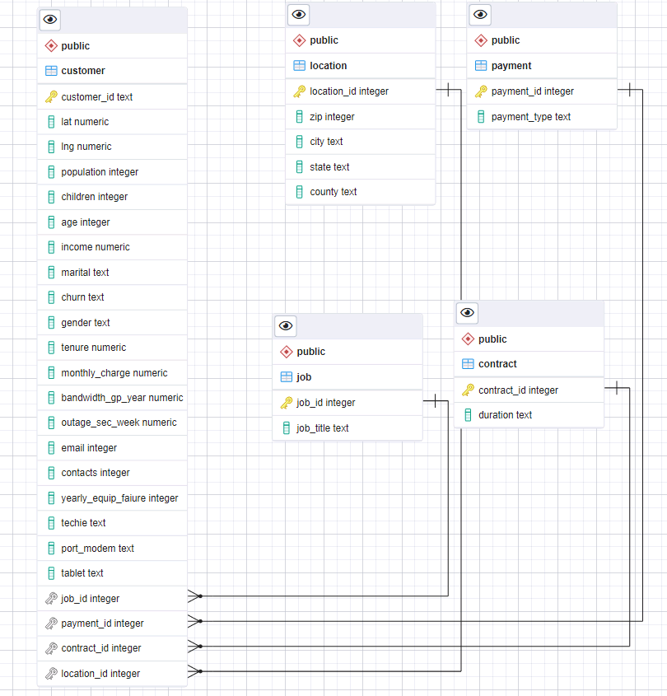

Part 3: Report

Outline of Exploration

Aligning Purpose and Function of Dashboard with Stakeholders’ Needs:
The dashboard was designed with a focus on understanding churn rates. From how family status impacts the use of add-on services, to how Internet Service impact churn rates. This aligns with the stakeholders’ need to grasp not just the overall churn numbers, but also the reasons behind them. Specifically, which demographic groups are most likely to churn. By allowing users to explore how internet service, gender, and family status (children, no children, married, not married) correlate with churn behavior, executives can gain insights that can help drive strategic decisions.

Justifying the Business Intelligence Tool
I selected Tableau for this analysis because of its ability to create interactive, user-friendly dashboards that can visually communicate complex data patterns to non-technical stakeholders. Tableau's ability to integrate multiple datasets and provide interactive visualizations made it a no brainer for my goal of translating data into business insights. It also provides easy accessibility features, like its colorblind-friendly palettes, ensuring that the dashboard is inclusive for all users, and its SQL code features allowed to create the necessary fields and meet task requirements.

Data Cleaning and Preparation
The data cleaning and preparation involved using SQL queries to combine and transform datasets from two different companies, IBM and WGU. This included cleaning up inconsistencies reformatting columns, changing values from with multiple options to a simple yes and no within pgAdmin and joining tables efficiently, and setting up calculated fields within. For example:
Joins: Since the WGU telecom data was split between multiple tables, I used SQL INNER JOIN and LEFT JOIN operations to merge tables based on customer id and location id within Tableau using the Convert to Custom SQL option. These joins allowed me to create one simple table to use for the wgu dataset without having to work with more then I needed.
Data transformations: I used UPDATE and CASE WHEN statements to standardize data values, such as changing “Single, Married, Widowed, Divorced, Never Married” responses into binary format (Single/Married), and to categorize customer into meaningful groups like Not Active and Active.
I performed aggregations (COUNT, SUM, AVG) to calculate churn rates and service usage by customer segment, allowing for more focused analysis in the dashboard.
In doing so, I was able to prepare the data and generate meaningful information that will help answer the questions being asked by the stakeholders .

Steps to Create the Dashboard:
The dashboard creation process involved several key steps:
I first created parameters for selecting different services, allowing users to toggle between services like device protection and streaming options. Then created calculated fields to display customer selections based on the chosen service, marital status and churn status. I used SQL query to create visualizations such as churn rate comparisons and used demographic filters like gender and dependent status to enhance interactivity. I even ensured accessibility with color-blind-friendly palettes and a layout that was intuitive, making it easy for stakeholders to explore and extract insights. I created each sheet in order to compare for example wgu internet service and then ibm internet service. I used the matching variables inorder to have an accurate comparison and kept that same process for the other sheets. Then for the dashboard I dragged all the sheets over and set maps as a filter allowing the user to filter by state.

Results of the Analysis:
The results of the analysis provided a few important details For example, SQL-based aggregations showed which internet services had the highest churn rates, while subqueries helped analyze how family status impacted the usage of add-on services. These findings enabled the dashboard to deliver actionable insights to executives, such as the need to update certain services or create targeted marketing campaigns for families.

Limitations of the Analysis:
One limitation of the analysis was the lack of consistent customer IDs between the WGU and IBM datasets, which made it impossible to perform a direct customer-level comparison across both companies. Instead, I relied on SQL joins and advanced techniques to create high-level comparisons using shared variables like service usage and demographics. Another limitation was some variables, like customer satisfaction, weren’t present in both datasets, which limited the scope of our analysis to certain demographic and service-based trends. Despite these limitations, the dashboard still provided valuable trends and actionable insights for decision-making.
Figures Title

Figure 1.
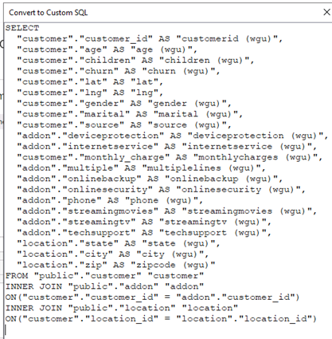

Figure 2.
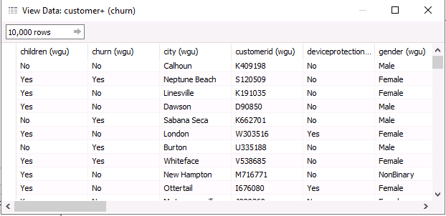

Figure 3.
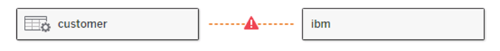

Figure 4.
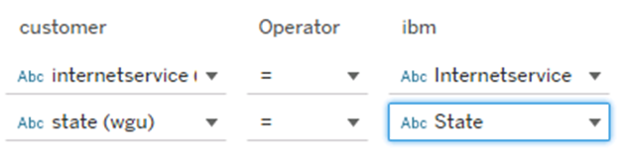

References
Ganger, K. (2024). Task 1 D206.
Ganger, K. A. (2024). Task 1 D209.
Ganger, K. A. (2024). Task 1 D210.
IBM. (2023, April 5). Telecommunications Industry Sample Data. (D. o. Development, Ed.) Retrieved from IBM Cognos Analytics with Watson: https://accelerator.ca.analytics.ibm.com/bi/?perspective=authoring&pathRef=.public_folders%2FIBM%2BAccelerator%2BCatalog%2FContent%2FDAT00148&id=i9710CF25EF75468D95FFFC7D57D45204&objRef=i9710CF25EF75468D95FFFC7D57D45204&action=run&format=HTML&cmPropStr=%7

